SHAW HALL MOVE-IN PASS

Please PRINT THIS PASS and place it in a visible location on your dashboard.

Residence Hall Assignment: Shaw Hall
201 Euclid Avenue
Syracuse, NY 13244

Day and Time: Sunday, July 3, 2022, 11 a.m. – 4 p.m.

This pass will help us ensure you are in the correct holding line. While most students are able to arrive and unload in less than 30 minutes, you should be prepared to wait up to 45 minutes in the holding line before unloading in front of Shaw Hall. In an effort to minimize this inconvenience, you are encouraged to arrive before 3 p.m.

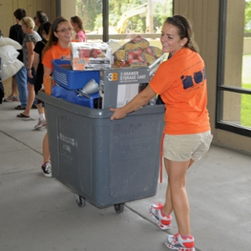
Once you arrive at the correct drop-off location:

- Driver must remain with vehicle at all times
- With car in holding line, student enters Shaw Hall to begin check-in
- Must bring a photo I.D. or Admission Letter to begin check-in
- Begin unloading car into gray bin when advanced to unloading zone
- Return gray bin to main floor as soon as soon as it is emptied

Directions to Campus/Shaw Hall
Address for Taxi Service/GPS:
Shaw Hall
201 Euclid Avenue
Syracuse, NY 13244

See below for detailed directions:

Directions to Syracuse University:
Most of Syracuse University’s residence halls are easily reached from Interstate 81, which runs north and south. Travelers on Interstate 81 should exit at Adams Street (Exit 18).

From Points East and West of Syracuse:
New York State Thruway Travelers (Route 90 East and West) should take Thruway Exit 36 (Interstate 81) and proceed south. From I-81S, follow directions below for ‘From Points North of Syracuse’.

From Points North of Syracuse:
Exit I-81S at Exit 18 (Adams Street). Keep left as you proceed down the ramp, and continue two blocks on Almond Street to Adams Street (Note: you will be driving underneath I-81). Turn left onto Adams Street. Please see below for specific directions to Shaw Hall below.

From Points South of Syracuse:
Exit I-81N at Exit 18 (Adams Street). Proceed down ramp and turn right onto Adams Street. Please see below for specific directions to Shaw Hall below.

Directions to Shaw Hall:
From Adams Street, drive straight up the hill and make a right onto Comstock Avenue. Continue on Comstock Avenue and then Shaw Hall will be on your left.

A holding line may form on Comstock Avenue. We appreciate your patience as we will quickly assist each car as they unload before directing families to park their vehicle.

Parking:
After dropping off your student and their belongings at Shaw Hall, please park in an open lot in close proximity to Shaw Hall. There are several lots nearby Shaw Hall that are free to park in on Sunday.

